*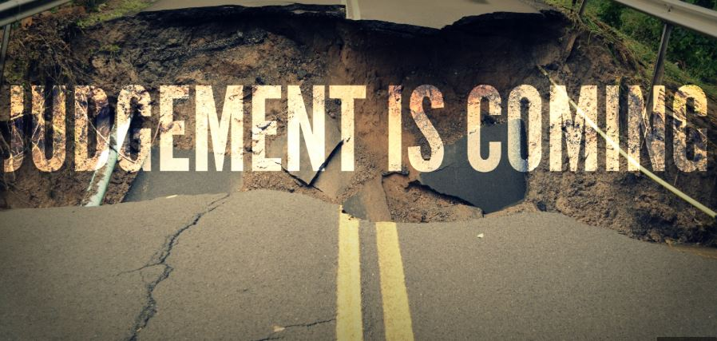*

The Coming Judgment

*2 Thessalonians 1:1-12*

A. What will Happen v3-10

* All Wrongs will be made Right v5-7
* Why does God allow Suffering in the world?
* We live in the Now and the “Not Yet”
* God is keeping Account and will make all things Right
* Jesus will come to Judge the Nations v7-10
* He will come in Person v7
* He will come in Glory v10
* He will come in Power v7, 10
* He will come in Justice v8-10

B. What we need to Learn

* Suffering is part of the Christian Life v3-5
* It is an Encouragement to others v4
* It is Evidence of God’s righteous judgment v5
* It makes you Worthy of the Gospel v5
* Hell is Real and Horrible
* The picture of Hell in Scripture is Frightening
* Worst part of Hell? Exclusion from the presence of Jesus!
* The Wrath of God is part of His Nature
* God is Love but He is also Just
* He does not send us to Hell; we send Ourselves
* Good News: We serve the Victor
* Once despised and rejected, Christ will come in Power and Glory
* We might experience suffering Now but we will Rule and Reign with Him for all Eternity
* He has Everything under control; He is Large and in Charge!

Honolulu Assembly of God • *Live Ready!* • November 3, 2024