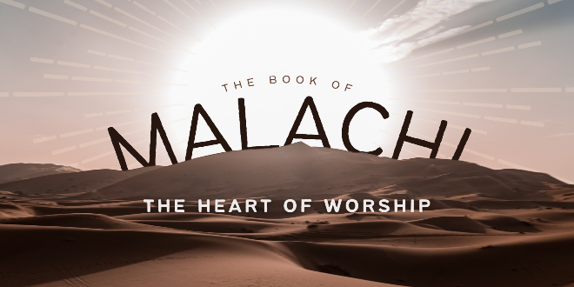

Unholy Worship

*Malachi 1:1-14*

A. **Unholy Worship Then** (430BC)

* God’s Love and Sovereign Choice v2-5
* Blemished Sacrifices v6-14
* They did not Revere God so they were willing to give Him their spiritual Junk
* Rather than Please God, they Offended Him
* Do you hear the Broken Heart of God?
* v11 God deserves the Best because He is the Greatest

B. **Unholy Worship Today** (2024AD)

* The Danger of Irreverent Worship
* The Problem of Pretense

C. Solution? **Give God your Best**

* Don’t give Him your Spiritual Leftovers
* When I enter enthusiastically into Praise and Worship on Sunday but live for Myself the rest of the week, I am offering Him my Spiritual Leftovers
* When I proclaim that Jesus Christ is Lord of my life but make my decisions based upon what I Want, I have placed spiritual Junk on the altar
* When I am willing to worship God but only at my Convenience,  
  I am offering Unholy Worship
* He deserves All the Honor and Reverence; Nothing and no one else should have First Place

Honolulu AG • *Living Right-side Up in an Upside-down World!* • August 4, 2024