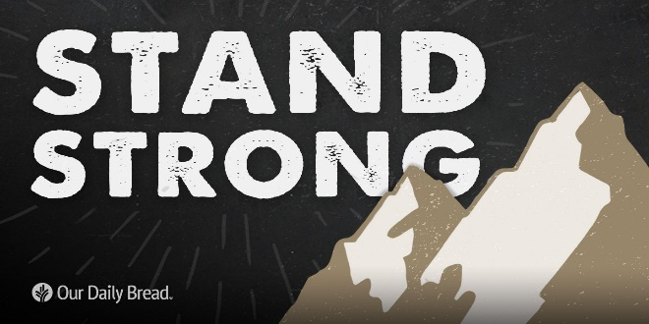

Stand Strong!

*Malachi 2:1-16*

A. **Unfaithful Leaders** v1-9

* Corrupted Leadership v1-3, 8-9
* God will send a Curse upon them and will rebuke their Descendants
* The Priest God Desires v4-7
* Levi Revered the Lord, walked in Peace and Righteousness, and turned many away from Sin
* Godly Leaders are needed Today
* We are God’s Ambassadors on earth

B. **Unfaithful People** v10-16

* Marital Divorce v13-16
* We have been influenced By the culture rather than Influencing it
* Spiritual Divorce v11-12
* Don’t ask God to Bless you if you are living in Rebellion to His word

C. Solution? **Stand Strong Today**

* Step Up to Faithfulness
* Return to your First Love
* Be Fully Committed
* Pursue God!

Honolulu AG • *Living Right-side Up in an Upside-down World!* • August 11, 2024