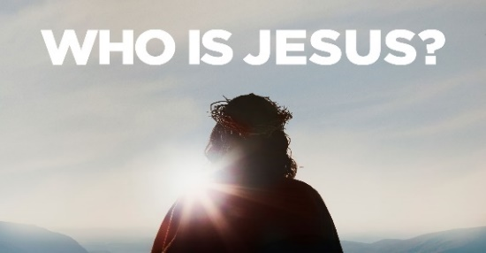

Jesus is Grace! *Ephesians 2:1-9*

1. We Receive Grace

* Before and After picture
* Before
* Dead in our transgression and sins v1
* Gratifying the Cravings of our sinful nature v3
* We were by nature objects of Wrath v3
* After
* He made us Alive with Christ v5
* He Raised us Up with Christ v6
* He Seated us in Heavenly Places with Christ v6
* Everything we Receive is because of Christ’s Grace v5, 7-8
* Grace is God’s Riches at Christ’s Expense
* We cannot Earn it, could never Deserve it, and are absolutely Unworthy of it v8-9
* We are Sinners saved by Grace

2. We Live Grace

* It is tempting to be Saved by Grace, but then try to Live by Works
* Problem? It is all based on my Efforts to please God
* The Cross + Nothing = Salvation; we can’t add Anything to Christ’s work. His grace is Sufficient

3. We Give Grace

* What we Receive, we must Give
* Tragedy: Many Christians are Saved by Grace but Judge others by the Law
* Key: Be Patient with others; others were patient with you

Honolulu Assembly of God • April 28, 2024