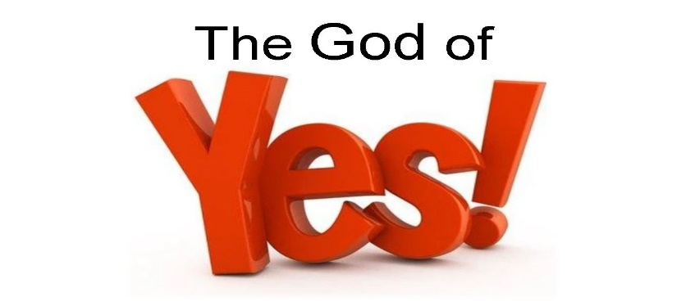

*2 Corinthians 1:20-21*

A. SayYes to God

* Saying Yes to God is the Gateway to Growth
* It is the foundation for Biblical Transformation
* It results in Going beyond the Natural to the Supernatural
* You can trust God because He is a Good God
* He loves you with an Everlasting love

B. SayYes to No

* There need to be some Boundaries in your life
* There are Activities, Behaviors, Attitudes, and Actions that are dangerous
* The Nos in the Word are there to Align you with God’s eternal Yes
* God has a Line of blessing and we don’t want to be out of Alignment
* God will not Leave you in a place of No
* The place of No will eventually lead you to the place of Yes

C. You are the Evidence of God’s Yes

* God put His Yes in You and Me
* Question: Do I have the Evidence of God’s Yes in my life?
* The World is hearing No all the time
* We need to declare God’s great Yes to Hurting people

D. The God of Yes is God Alone

* Look to Him; there is no Other Isaiah 43:10-11
* God is Faithful

Honolulu Assembly of God • January 26, 2025