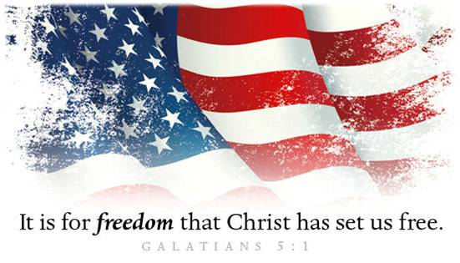

*Celebrate Freedom!*

A. What is our Responsibility?

* Speakup
* Vote
* Pray

B. Our Freedom in Christ; Galatians 5:1

* Freedom from Sin and Bondage to Satan
* Jesus Christ has set us Free
* Why? To Live in Freedom
* Freedom to live in Kingdom of Righteousness
* Freedom to live as a Child of God
* Freedom to live a Victorious Christian Life
* Warning (v1, 13): Do not become Enslaved again!
* Instead of living in Sin, we are now living for Self
* Key: Notpolitical Independence but spiritual Dependence
* Paradox: Freedom and Slavery
* To be truly Independent, we must become absolutely Dependent upon Jesus Christ
* When we choose to do what We want, it leads to Slavery
* To become truly free, you must surrender Your “freedom” and become a Slave

John Quincy Adams (*6th President, son of 2nd*): “The highest, the transcendent glory of the American Revolution was this — it connected, in one indissoluble bond the principles of civil government with the precepts of Christianity.”

Charles Finney (*Revivalist, leader in 2nd Great Awakenings*): “The time has come that Christians must vote for honest men and take consistent ground in politics or the Lord will curse them…Christians have been exceedingly guilty in this matter. But the time has come when they must act differently…God will bless or curse this nation, according to the course Christians take.”

Honolulu Assembly of God • June 30, 2024

**The Christian’s Declaration of Independence**

I am free from Failure, for “I can do all things  
through Christ who strengthens me” Philippians 4:13.

I am free from Want, for “My God shall supply all my needs  
according to His riches in glory by Christ Jesus” Philippians 4:19.

I am free from Fear, for “God has not given us a spirit of fear,  
but of power, and of love, and of a sound mind” 2 Timothy 1:7.

I am free from Doubt, for “God has given to every man  
the measure of faith” Romans 12:3.

I am free from Weakness,  
for “The Lord is the strength of my life” Psalm 27:1.

I am free from the Power of Satan, for “Greater is  
He that is in me than he that is in the world” 1 John 4:4.

I am free from Defeat, for “God always leads us  
in triumphal procession in Christ” 2 Corinthians 2:14.

I am free from Ignorance, for “Christ Jesus  
has become for us wisdom from God” 1 Corinthians 1:30.

I am free from the Curse of Sin, for “the blood of Jesus,  
His Son, purifies us from all sin” 1 John 1:7.

I am free from Worry, for I can  
“Cast all (my) cares upon Him, for He cares for (me)” 1 Peter 5:7.

I am free from Bondage, for “Where the Spirit of the Lord is,  
there is freedom” 2 Corinthians 3:17.

I am free from Condemnation, for “There is therefore now  
no condemnation to them which are in Christ Jesus,  
who walk not after the flesh, but after the Spirit” Romans 8:1.