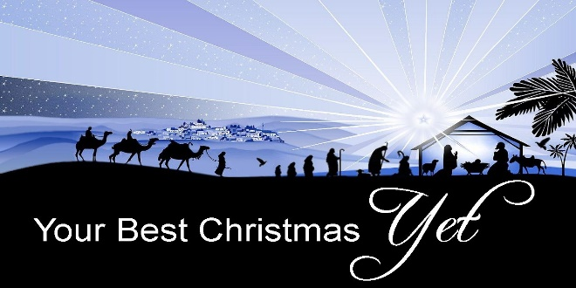

Value over Rejection!

*Luke 2:8-20*

A. The Shepherds (4BC)

* Their very Ordinary life in 1st century Bethlehem v8
* A Common existence
* Main duty: Protect and Provide for their flock
* Their Extraordinary encounter with Angels v9-14
* The night sky burst forth with the Glory of the Lord
* The great Company of Heavenly Hosts began Praising God
* The shepherds were in Awe of this marvelous sight
* Why did God give His glorious news to Shepherds?
* Shepherds were considered Unclean
* They were looked on with Suspicion and Distrust
* They were Rough, Uneducated men
* God is not interested in Who you are in the eyes of the world but in where your Heart is
* Their Hurried and Holy visit to Bethlehem v15-20
* Their Obedience v15-16
* Their Worship v16, 20
* Their Excitement v17-18, 20

B. Us (2024)

* God Knows you and you are Valuable to Him
* How many feel like you are a very “Ordinary” person?
* Your Life matters because God Loves you
* Your Faith and Trust in God can make a difference
* Like the shepherds, you can overflow with Excitement and Joy
* Like the shepherds, you can overflow with Worship
* They Worshipped God by giving Him Praise v20
* And by telling everyone the Good News of salvation v17

Honolulu Assembly of God • *Your Best Christmas Yet!* • December 15, 2024

*Christmas means*

He descended that we might ascend  
(John 6:38; 14:3).

He became poor that we might become rich  
(2 Corinthians 8:9; James 2:5).

He was born that we might be born again  
(John 1:14; 3:2, 7).

He became a servant that we might become sons and daughters  
(Philippians 2:7; Galatians 4:6-7).

He had no home that we might have a home in heaven  
(Matthew 8:20; John 14:2).

He was hungry that we might be fed  
(Matthew 4:2; John 6:50).

He was thirsty that we might be satisfied  
(John 19:26).

He was stripped that we might be clothed  
(Matthew 27:28; Galatians 3:27).

He was forsaken that we might be restored  
(Matthew 27:26; 28:20).

He was sad that we might become glad  
(Isaiah 53:3; Philippians 4:4).

He was bound that we might be set free  
(Matthew 27:2; John 8:32-36).

He was made sin that we might be made righteous  
(2 Corinthians 5:21).

He died that we might live  
(John 5:24-25).

He came down that we might be caught up  
(1 Thessalonians 4:16-17).

