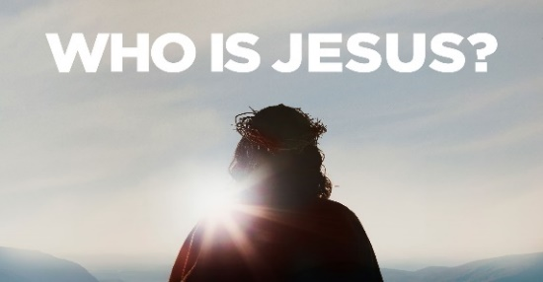

Jesus is All you need! *John 8:58*

1. Salvation

* He is the Gate; 10:9
* Jesus is the Only means of coming home to the Father
* He is the Way, Truth, and Life; 14:6
* He is the Only Way: the Exclusivity of the Gospel is a Stumbling block to many

2. Provision: He is the Bread of Life; 6:48

* There are two kinds of food: food for the Body, which is important, and food for the Spirit, which is essential
* Physical food only Sustains life but Jesus gives Eternal life

3. Protection: He is the Good Shepherd; 10:11-14

* Jesus is not only the gate that welcomes us Home to eternal life, He is the one who Leads us along the way
* He lays down his Life for His sheep

4. Guidance and Wisdom: He is the Light of the world; 8:12

* People who cannot see the light are those who are Blind
* Light and darkness represent Belief and Unbelief

5. Vitality: He is the True Vine; 15:1-5

* You need spiritual Nourishment
* You must be Daily plugged into Jesus and His Word

6. Life; 11:21-25

* He is the Resurrection
* He can raise you up spiritually in Salvation
* He will raise us up physically after we Die
* He is the Life
* Abundant life Now; 10:10
* Eternal life Forever; 14:1-3

Honolulu Assembly of God • *Who is Jesus?* • June 9, 2024