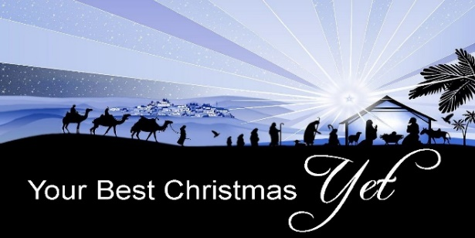

Passion over Contentment!

*Matthew 2:1-12*

A. The Givers and their Gifts (4BC)

* Their Background
* Magi
* Kings
* Their Significance
* They were Foreigners, not Jews
* The local Jewish religious elite were not there
* The Wise Men were 1st of the Gentiles to seek Christ
* Their Actions
* They Followed the Star v2
* They Bowed down and Worshipped Him v11
* They presented to Him lavish Gifts v11
* Their Gifts
* Gold signified Christ’s Royalty
* Frankincense signified His Divinity
* Myrrh signified His Humanity

B. Our Gifts (2024)

* Resources
* Our Time
* Our Talent
* Our Treasure
* Worship
* Like the Wise Men, bow your Heart and Body before Him
* Give Him All the praise and glory and honor
* Yourself
* Give Jesus Christ your life because He paid the Price and Penalty for sin
* As King, Jesus Christ Deserves your All

Honolulu Assembly of God • *Your Best Christmas Yet!* • December 22, 2024